Asian Journal of Medical and Pharmaceutical Researches (AJMPR)

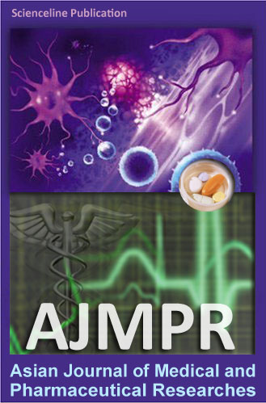
An open access peer-review publication wich publishes the results of original scientific researches, reviews and short communications, (in full text) in all fields of Medical and Pharmaceutical Sciences in electronic format (Quarterly).

Signed copy must to be sent by mail to:
editor@ajmpr.science-line.com or ajmpr.editors@gmail.com

DECLARATION OF THE AUTHORS

All authors of the manuscript titled:
……………………………………………………………………………………………………..
……………………

intended for publication in Asian Journal of Medical and Pharmaceutical Researches (AJMPR) declare that

- they agree to its publication after any amendments arising from the peer review
- they agree to the posting of the full text of this work on the web page of the journal and to the inclusions of references in databases available on the internet
- no results of other researchers were used in the submitted manuscript without their consent, proper citation or acknowledgement of their cooperation or material provided
- the results (or any part of them) used in the manuscript have not been sent for publication to any other journal nor have they already been published (or if so, that the relevant works are cited in this manuscript)
- submission of the manuscript for publication was completed in accordance with the publishing regulations pertaining to their workplace
- experiments performed comply with current laws and written consent of Scientific Ethnic Committee / Human and Animal Care Authority is available (as it is mentioned in the manuscript submitted)

AUTHORS OF THE MANUSCRIPT

E-mail name date signature

Updated in December, 2011
Available as PDF & WORD document at http://www.ajmpr.science-line.com/index/

